GOVERNMENT DEGREE COLLEGE, RAYACHOTY
REPORT ON ANTI-RAGGING AWARENESS PROGRAM
Held at GDC, RAYACHOTY ON 10-03-2023

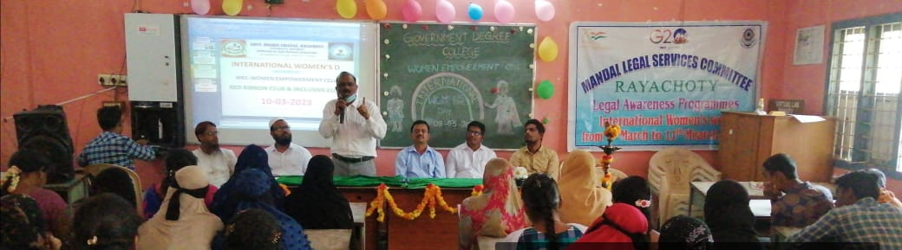

The Inclusive Club Cell along with Red Ribbon Club & Women Empowerment Cell organized a Program on the topic of “ Awareness on Anti Ragging" on 10th March 2023 with collaboration of Mandal Legal Services Committee Rayachoty. Vice Principal of the College Presided over the function.
The guest speaker Advocate Eshwarayya Garu in his address emphasized on the significance of constitutional provisions, special Laws related to women’s problems and he referred to various acts for the protection of women and said that you can avoid the atrocities against you by knowing these acts. He also explained the bad consequences of ragging and urged the students not to spoil their precious life due to this ragging. If they are found guilty of ragging, they will face imprisonment from two months to two years and they will also be deprived of government jobs.
Another Guest, Advocate Nagaraju Garu explained the disadvantages of ragging and urged the students not to spoil their precious life due to this ragging. If they are found guilty of ragging, they will be imprisoned for two months to two years and they will be deprived of government jobs.
Mr. Muhammad Hidayatulla Advocate said that the biggest disadvantages of womens are that they do not know the laws, due to which they live victimized by oppression.
On this occasion, Dr.Muniya Naik, RRC Coordinator Dr.Venkata Rao &WEC Coordinator Mrs. Shantha kumari expressed their thoughts.
Prizes were distributed by Chief Guests among the students who participated in various Competitions like Elocution, Essay Writing and Rangoli which was organized on the occasion of Women’s Day.
to the winners of competitions on the occasion of Women's Day. College Red Ribbon Club Coordinator Dr.Venkata Rao garu and Women Empowerment Cell Coordinator Mrs. Shantha kumari, Inclusive Club Coordinator Dr. S.Farooq Basha and NSS Coordinator Mr. B.Kiran Kumar, and othersTeaching &Non Teaching Staff and Students are participated to success the Programm.

Photos of the Program

